**GIT-HOL-3**

**CODE**

**BRANCHING**

# Create a new branch

$git branch GitNewBranch

# List all local and remote branches

$git branch -a

# Switch to the newly created branch

$git checkout GitNewBranch

# Create and add a file with some contents

$echo "This is a file in GitNewBranch" > branchfile.txt

# Add the file to staging

$git add branchfile.txt

# Commit the changes to the branch

$git commit -m "Added branchfile.txt in GitNewBranch"

# Check status

$git status

**OUTPUT**

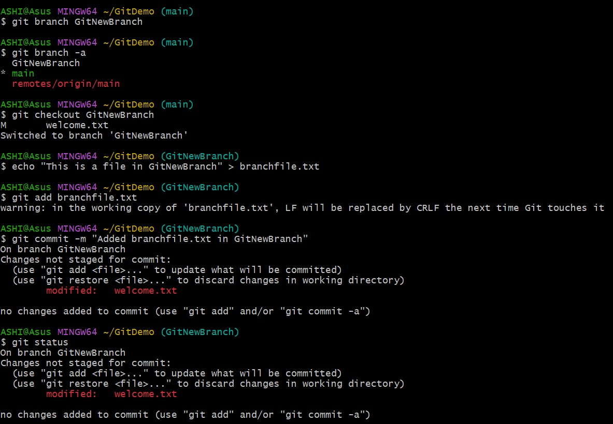

**MERGING**

# Switch back to master (or main, if your repo uses main)

$git checkout main

# See differences between trunk (main) and branch

$git diff main GitNewBranch

# Visual differences using P4Merge (ensure P4Merge is installed and configured)

$git mergetool

# Merge the branch into main

$git merge GitNewBranch

# View merge history visually

$git log --oneline --graph --decorate

# Delete the branch after merging

$git branch -d GitNewBranch

# Check status after merge

$git status

**OUTPUT**

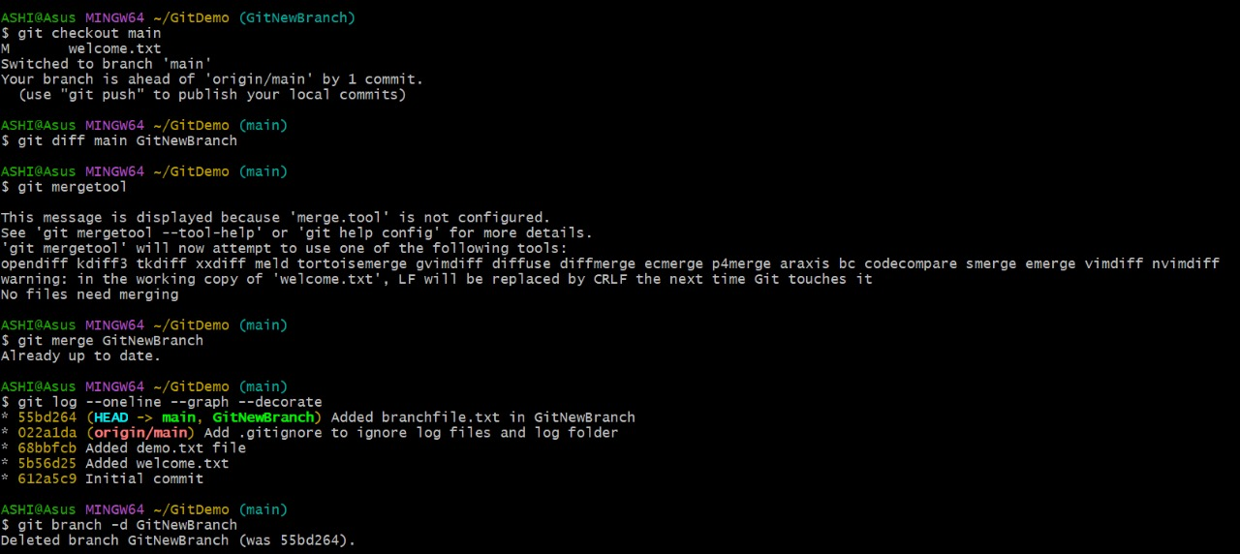

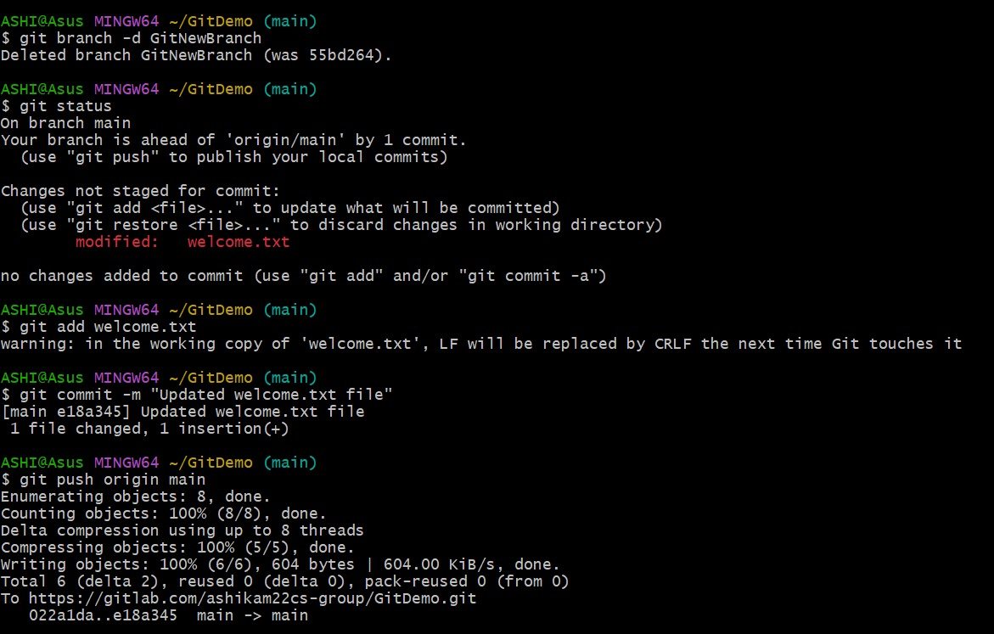

$git add welcome.txt

$git commit -m "Updated welcome.txt file"

$git push origin main

$git add welcome.txt

$git commit -m "Update welcome.txt"

$git push origin main

